Epsom & Ewell F.C.
7
v
Knaphill
Saturday, 24th September 2016 – 3.00 p.m.
Good afternoon. We host Knaphill this afternoon in a League match and welcome their players, supporters and officials and of course our own hardy followers.

Our opponents have won 2-1 on their last two visits to High Road but in significantly differing circumstances. Back in April 2015 it took a fantastic last minute strike for them to claim the points on a day when we had led and deserved a draw, while last season we almost got a draw but on that occasion didn’t deserve it, having to play much of the match with ten men after our keeper Adrian Jones was sent off, conceding a penalty at the same time, although it should be noted that we looked quite good while we still had eleven on the field!

It was a day our Captain Dan Dean won’t forget in a hurry as he went in goal and emerged unscathed from two penalties. One was placed wide but the other was well saved and in the end it was a cross that flew over everyone and into the far corner that broke our resistance, followed by a good winning goal. In fact all three of our matches at High Road against Knaphill have finished 2-1, as we won our first ever meeting in a League Cup tie. I wonder what the odds are on another!

We were last here two weeks ago for an attritional but competitive 0-0 draw with Camberley Town, which was probably a fair result by the end. We then travelled to Ash United last Saturday for a League match with Badshot Lea and came away with a 4-1 win that was about right on the balance of play, although we required two late goals to make it happen.

Our next fixture is on Tuesday when we visit Westfield, assuming they do not draw with Haywards Heath in the Vase today. They have started this season well and as we have not yet scored in three visits to their refurbished ground this will be another tough fixture. A third tough match in seven days then awaits us as we visit Walton & Hersham next Saturday. Older supporters will recall our last visit there during our relegation season of 2003/04 when we had our keeper Dave Hyatt sent off early and we lost 8-0. This was the only time we have conceded eight goals since 1968!!

As I write, the vagaries of the fixture list ensures that we now have no home match for six weeks, until we are scheduled to host Sutton Common Rovers on Tuesday 8th November!! It is possible we could have a home match in the F.A. Vase on Saturday 22nd October (this draw will be made on Monday, check the website) but if not we will be facing a large spell away from Chipstead.

In view of this, it is even more important that we receive match and player sponsors. The available lists are located towards the back of the programme. Please help your club!

Enjoy the game!

Rich

You can follow us on Facebook: www.facebook.com/epsomandewellfc Twitter: @EEFCOfficial and
Instagram at: www.instagram.com/epsomandewellfc We also have a Youtube channel now!

Cover photos by Gemma Jarman

- Assistant Manager Matt Smith scores our fourth goal at Badshot Lea on Saturday

- Matt celebrates his goal at Badshot Lea

Cherry Red Records Combined Counties League
Premier Division Table 2016/17
including Weds 21st September | P | W | D | L | F | A | Pts | GD | H | A
Hartley Wintney | 10 | 8 | 1 | 1 | 30 | 12 | 25 | +18 | 18/3 | 10/12
Westfield | 8 | 8 | 0 | 0 | 23 | 3 | 24 | +20 | 18/2 | 27/9
Walton & Hersham | 8 | 6 | 2 | 0 | 13 | 5 | 20 | +8 | 4/3 | 1/10
Bedfont Sports | 9 | 6 | 1 | 2 | 23 | 16 | 19 | +7 | 19/11 | 7/2
Knaphill | 10 | 6 | 0 | 4 | 22 | 16 | 18 | +6 | 24/9 | 8/4
Hanworth Villa | 10 | 5 | 2 | 3 | 14 | 11 | 17 | +3 | 13/12 | 14/1
Windsor | 10 | 4 | 3 | 3 | 18 | 17 | 15 | +1 | 15/11 | 1-2
Epsom & Ewell | 8 | 4 | 1 | 3 | 25 | 16 | 13 | +9 | X | X
Guildford City | 7 | 4 | 0 | 3 | 21 | 12 | 12 | +9 | 17/1 | 5/11
CB Hounslow United | 7 | 4 | 0 | 3 | 12 | 10 | 12 | +2 | 1-5 | 12/11
Camberley Town | 8 | 3 | 2 | 3 | 18 | 10 | 11 | +8 | 0-0 | 1/4
Horley Town | 7 | 3 | 2 | 2 | 12 | 12 | 11 | 0 | 3-0 | 17/4
Spelthorne Sports | 7 | 2 | 3 | 2 | 9 | 9 | 9 | 0 | 7/1 | 25/2
Abbey Rangers | 9 | 3 | 0 | 6 | 15 | 20 | 9 | -5 | 7-1 | 3/12
Chertsey Town | 7 | 3 | 0 | 4 | 7 | 17 | 9 | -10 | 17/12 | 11/2
Colliers Wood United | 7 | 2 | 2 | 3 | 15 | 14 | 8 | +1 | 14/4 | 0-5
Raynes Park Vale | 10 | 2 | 2 | 6 | 13 | 22 | 8 | -9 | 27/12 | 25/10
Sutton Common Rovers | 6 | 2 | 1 | 3 | 7 | 14 | 7 | -7 | 8/11 | 2/1
Farnham Town | 10 | 2 | 1 | 7 | 17 | 28 | 7 | -11 | 25/3 | 8/10
AFC Hayes | 7 | 2 | 0 | 5 | 10 | 15 | 6 | -5 | 26/11 | 28/1
North Greenford United | 6 | 1 | 2 | 3 | 6 | 8 | 5 | -2 | 22/4 | 15/10
Badshot Lea | 11 | 1 | 1 | 9 | 13 | 33 | 4 | -20 | 4/2 | 4-1
Bedfont & Feltham | 8 | 1 | 0 | 7 | 10 | 33 | 3 | -23 | 21/1 | 9-2

Lucky Day? - 24th September
Played 16 - Won 7 Drawn 0 Lost 9 - For 34 Against 29 - PPG 1.31 - Average
Our Club record against Knaphill
Played 6 - Won 3 Drawn 1 Lost 2 - For 12 Against 9 - PPG 1.67 - Above Average
Largest wins and losses against Knaphill
20th September 2014 - W 4-1 – Combined Counties League (A)
18th April 2015 - L 1-2 - Combined Counties League (H)
12th March 2016 - L 1-2 - Combined Counties League (H)
Their Last Visit
Saturday 12th March 2016 - L 1-2 - Combined Counties League

Club Manager – Glyn Mandeville
Hi all and welcome to all from Knaphill FC. I hope you enjoy the game and I wish you all a safe trip home.

We come into today's game in some sort of form. How we have managed to do this with so many injuries, suspensions, illnesses and also player holidays is a real testament to the lads we have at this club. As a Manager you don't realise how lucky you are when things like this happen but to have such a great bunch I feel very fortunate.

We have three very tough games coming up in a row with many more to follow, and we are looking to strengthen when we can, so are always looking for the right player.

I would also like to thank Mel Tough for the new away kit. It looked great and the lads loved it.

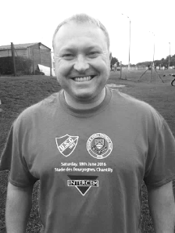
Also thanks to everyone for their continued support.

Manders

Milestones
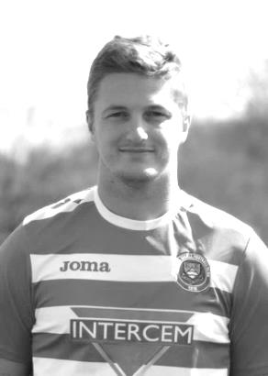
After a slight delay Craig Hastings made his 50th appearance at Badshot Lea last Saturday, becoming the 259th player in club history to reach that mark. That might sound like a lot of people, but with nearly 1,600 players representing the Salts over the last 92 senior seasons, it is a fine achievement. Craig made his debut in August 2015 when we drew 2-2 at home to Windsor.

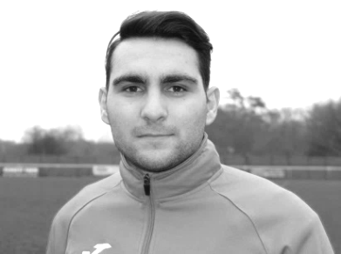
Over the next week or two we should see two other players reaching their 50th appearances. Making his 49th today if selected is Savvas ‘Agi’ Panayiotou whilst already on 49 appearances but suspended for the next three matches is Daryl Cooper-Smith. Both made their debuts on the same day, also against Windsor on 3rd January 2015 and have proven to be valuable players for us. Agi has scored seven times for us while playing in a number of positions. Both also had a very brief spell away from us, Agi with Chipstead and Daryl with Leatherhead. Daryl has scored 33 times, with 13 already this season. This gives him a better scoring ratio than our legendary record goal scorer Tommy Tuite (0.673 goals per game v 0.672) but of course Tommy kept that rate up for 12 seasons, so Daryl still has plenty of challenges ahead of him on that front!

Latest Results and Fixtures
F.A. Vase First Qualifying Round – Friday 9th September
Badshot Lea | 3-1 | Farnham Town
Combined Counties League – Saturday 10th September
Epsom & Ewell | 0-0 | Camberley Town
Hartley Wintney | 3-1 | Knaphill
Walton & Hersham | 1-0 | Sutton Common Rovers
F.A. Vase First Qualifying Round – Saturday 10th September
AFC Hayes | 2-2+ | Crawley Green
Crawley Green win 4-2 on penalties
Arundel | 1-2 | Westfield
Bedfont & Feltham | 3-0 | Sandhurst Town
Bedford | 0-1 | CB Hounslow United
Bridon Ropes | 2-1 | Colliers Wood United
Chertsey Town | 1-2 | Lydney Town
Daventry Town | 3-1 | Windsor
Guildford City | 2-1 | Eastbourne United
Guildford City removed from the Vase for playing an ineligible player
Hanworth Villa | 0-4 | Bedfont Sports
Horley Town | 4-0 | Hassocks
Raynes Park Vale | 1-2 | Haywards Heath Town
Shrivenham | 2-3 | Abbey Rangers
Spelthorne Sports | 0-0+ | Tring Athletic
Stotfold | 2-2+ | North Greenford United
Combined Counties League – Monday 12th September
Abbey Rangers | 2-0 | Windsor
F.A.Vase First Qualifying Round Replays – Tuesday 13th September
North Greenford United | 4-0 | Stotfold
Tring Athletic | 2-0 | Spelthorne Sports
Combined Counties League – Tuesday 13th September
Hanworth Villa | 1-2 | Walton & Hersham
Knaphill | 5-0 | Chertsey Town
Westfield | 5-0 | Raynes Park Vale
Combined Counties League – Wednesday 14th September
Colliers Wood United | 0-2 | Bedfont Sports
Guildford City | 7-3 | Farnham Town
F.A. Cup Second Qualifying Round – Saturday 17th September
Merstham | 0-0 | Colliers Wood United
Combined Counties League – Saturday 17th September
Badshot Lea | 1-4 | Epsom & Ewell
Latest Results and Fixtures
Combined Counties League – Saturday 17th September
Bedfont Sports | 1-2 | Sutton Common Rovers
Camberley Town | 0-0 | North Greenford United
CB Hounslow United | 2-1 | Windsor
Farnham Town | 5-2 | Bedfont & Feltham
Guildford City | 0-1 | Hanworth Villa
Horley Town | 1-2 | Hartley Wintney
Knaphill | 2-1 | Abbey Rangers
Raynes Park Vale | 2-3 | Walton & Hersham
Spelthorne Sports | 0-2 | Westfield
Combined Counties League – Tuesday 20th September
Bedfont & Feltham | 1-5 | Camberley Town
Chertsey Town | 1-2 | Hanworth Villa
Horley Town | 3-2 | Abbey Rangers
Raynes Park Vale | 2-0 | Farnham Town
Westfield | 2-1 | Knaphill
F.A. Cup Second Qualifying Round Replay – Wednesday 21st Sept
Colliers Wood United | 1-2+ | Merstham
Combined Counties League – Wednesday 21st September
Bedfont Sports | 4-3 | Badshot Lea
F.A. Vase Second Qualifying Round – Saturday 24th September
Abbey Rangers | V | Badshot Lea
Bedfont & Feltham | V | Sun Sports
Frimley Green | V | Walton & Hersham
Horley Town | V | Selsey
North Greenford United | V | Oxhey Jets
Thrapston Town | V | CB Hounslow United
Westfield | V | Haywards Heath Town
Combined Counties League Cup 1st Round – Saturday 24th September
Worcester Park | V | Dorking
Combined Counties League – Saturday 24th September
Epsom & Ewell | V | Knaphill
Hanworth Villa | V | Colliers Wood United
Raynes Park Vale | V | Chertsey Town
Spelthorne Sports | V | Guildford City
Sutton Common Rovers | V | Camberley Town
Windsor | V | Farnham Town
F.A. Vase Second Qualifying Round – Sunday 25th September
Wellingborough Town | V | Bedfont Sports

From behind the goal
Epsom & Ewell 0 - 0 Camberley Town
Combined Counties League - Premier Division - Saturday 10th September 2016

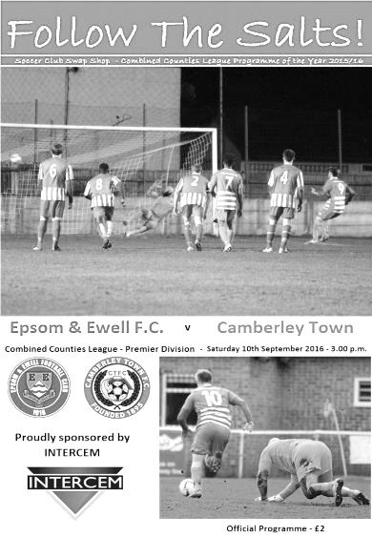
Salts finish strongly but a point is a fair result

The first of our regular meetings with Camberley Town took place on Saturday at High Road on a wet and blustery day and was regrettably watched by just 29 spectators, our third lowest Saturday home attendance in club history.

It might have been a little wet but it was unclear why so very few decided to come along this day to watch two teams that made up half of last season's top four. In such circumstances I always hope to be able to report on a pulsating match, full of incident and fine football to explain to the absentees what they had missed, but on a day that became increasingly difficult for football there was little of real note to report with exception our third consecutive clean sheet; a vast improvement on our early season "open door" policy.

We made one change to the eleven who had started the League Cup win over Abbey Rangers four days previously with Alex McKay coming in for the suspended Sam Robinson, but we didn't really create a lot in the first half and by the end of the period were probably a little fortunate to remain on level terms. An early communication error between Matt Tanton and Michael Eacott allowed a visiting striker to get between them but Eacott recovered to block the effort. He was out quickly on the quarter of an hour mark to smother another attack just as they broke through our defensive line but the game then stopped for a few minutes following a clash of heads between McKay and Camberley's Matt Bunyan which left both swathed in bandages but able to return after treatment.

It took eight minutes before McKay was able to return to the action and his first touch from that point almost put us ahead as he headed a free kick just wide of Stuart Norman's left hand post but we had suffered a scare of our own moments earlier when Eacott was outjumped and the ball required a clearance off our line, during which a concerted and simultaneous appeal for handball came from the visiting players and the bench. I'll be honest I feared the worst at that point but after what seemed an age it was apparent that we were still playing on!

Daryl Cooper-Smith had a half chance from an Agi Panayiotou corner, meeting the ball at the near post but glancing his header just beyond the far post. It wasn't long before Eacott was back in action though and although he fumbled a low shot in, he recovered to block the rebound which appeared to then cannon off the striker and loop over the bar somewhat

fortuitously. Maybe it was a belated present for our keeper who had celebrated his 21st birthday two days previously!

One person who was less fortunate was our Captain Dan Dean who received a booking in the 36th minute, largely due to appeals from the visiting bench although from the free kick a far post header was saved by Eacott once again. Panayiotou got a powerful shot on target six minutes later but Norman was well positioned to make the save before it was the turn of the Camberley Captain Dan Jewell to pick up a yellow card for fouling Matt Tanton. Just on half time a right wing attack was pulled back to an oncoming striker but Dean made a saving challenge to clear the danger for a corner and the teams went in level at the break.

The second half would be more even as we worked hard to nullify the visitors threats and started to cause a bit more trouble ourselves. Rob Hendry made a good run down the left wing before being taken out and then from the right an Adam Heagney cross was deflected into a very dangerous position, requiring an emergency clearance by a defender. Unfortunately our deliveries were not causing much trouble and we changed things around a little with Jordan Gallagher coming on for the battered McKay as we tweaked the formation.

This enabled Hendry to get further forward and his good run set up Cooper-Smith on the edge of the area but as he attempted to beat a defender the ball squirted across the edge of the penalty area to Reisse Griffin but his low shot was well blocked by Norman. Panayiotou lost possession in an important area and the visitors broke on goal but Eacott was there once again to block the danger. Tom Neale came on for Cooper-Smith and we almost scored a great goal from a Dean free kick that ended with Hendry producing a flying header that Norman tipped out for a corner. It may just have been going wide but it was a great effort by striker and keeper alike. Griffin hit a good volley against one of his team mates soon after this and as we sensed we could get more out of this game than a point, Gallagher set up Tanton on the overlap but he sliced his cross over the bar from a good position.

The final action of the match occurred on the edge of the Camberley penalty area when Neale latched on to a good pass only to be fouled by Norman who was booked for the challenge. It wasn't seen by the referee at first and required the intervention of the Assistant to be given in the first place. However, the free kick was eventually positioned some eight yards out from the penalty area and for some reason we didn't seem to query it, when it was obvious that the foul had occurred in the semi-circle just a yard outside the box. As Hendry blazed the free kick over the bar it was more frustrating knowing that it should have been taken from a far more dangerous position, yet we just seemed to accept it.

And at the end we had to accept just the one point. On the balance of play the visitors had been the better team in the first half, but our second half display was the stronger of the two and we may have pinched it at the end. It was a pity that we were unable to give Matt Farrell a win to mark his hundredth appearance for the club but that would have been harsh on the visitors. Ultimately the club record 89th encounter between the teams was high on effort but low in quality and will not live long in the memory.

Epsom and Ewell: Michael Eacott, Matt Tanton, Adam Heagney, James Taylor,
Dan Dean (c), Alex McKay, Rob Hendry, Matt Farrell, Daryl Cooper-Smith,
Savvas 'Agi' Panayiotou, Reisse Griffin

Subs: Jordan Gallagher for McKay (66), Tom Neale for Cooper-Smith (78)

Club Records - 24th September
Date | Day | Competition |  | Opponents |  | Scorers
24/09/27 | Sat | London League | H | Callender Athletic | 6-4 | R.Marlow (2), J.Parr (2), F.Behn, C.Taylor
24/09/32 | Sat | London League Cup 2 | H | P.O.Engineers | 5-1 | B.Williams (3), B.Marlow, B.Gill (pen)
24/09/38 | Sat | Amateur Cup Prelim Round | H | Redhill | 1-2 | B.Heal
24/09/49 | Sat | Corinthian League | A | Erith & Belvedere | 0-3
24/09/55 | Sat | F.A. Cup 1q | H | Dover | 3-2 | J.Sorensen (pen), D.Hermitage, G.Cairns
24/09/60 | Sat | Surrey Senior Cup 1q | A | Carshalton F.C. | 7-1 | D.Wells, o.g., B.Hawkins (2), K.MacDonald (2), P.Wood
24/09/96 | Sat | Amateur Cup Prelim Round | H | Ulysses | 1-3 | J.McNaught (pen)
24/09/77 | Sat | Isthmian League 2 | A | Molesey | 2-3 | G.Butler, R.Parkin
24/09/83 | Sat | Isthmian League 1 | H | Hornchurch | 2-1 | P.Harding (2)
24/09/85 | Tue | Isthmian League  Premier Division | H | Farnborough Town | 0-1
24/09/88 | Sat | Isthmian League 2s | H | Feltham | 4-0 | B.Perkins (2), M.Flemington, T.Tweedy
24/09/91 | Tue | Isthmian League 3 | A | Thame United | 0-1
24/09/94 | Sat | Isthmian League 3 | H | Lewes | 0-1
24/09/05 | Sat | Isthmian League 2 | A | Chalfont St Peter | 3-2 | D.Marvell (2, 1pen), A.Stones
24/09/11 | Sat | F.A. Vase 2q | A | Ringmer | 0-2
24/09/13 | Tue | Combined Counties  Premier Division | H | Wembley | 0-2
Historical Decades
Date | Day | Competition |  | Opponents |  | Scorers
90 years ago – Epsom Town F.C.
25/09/26 | Sat | Surrey Senior League | A | Camberley & Yorktown | 1-1 | R.Marlow
80 years ago – Epsom F.C.
26/09/36 | Sat | Amateur Cup Prelim Round | A | Banstead Mental Hospital | 6-0 | T.Rochester (2 pens), T.Dunne (2), J.Morgan, B.Randall
70 years ago – Epsom F.C.
21/09/46 | Sat | F.A. Cup Prelim Round | H | Met Police | 0-5
60 years ago – Epsom F.C.
22/09/56 | Sat | Corinthian League | H | Edgware Town | 4-1 | J.Bangs (2), R.Colfar, G.Mitchell
50 years ago – Epsom & Ewell F.C.
24/09/66 | Sat | Amateur Cup Prelim Round | H | Ulysses | 1-3 | J.McNaught (pen)
40 years ago – Epsom & Ewell F.C.
25/09/76 | Sat | Surrey Senior Cup 1q | A | Worplesdon | 5-2 | J.Eales (2), G.O'Rourke, T.Tuite, M.Peters
30 years ago – Epsom & Ewell F.C.
23/09/86 | Tue | Isthmian League Cup 1 | H | Southwick | 0-2
20 years ago – Epsom & Ewell F.C.
21/09/96 | Sat | Isthmian League 3 | H | Kingsbury Town | 1-1 | M.Jones
10 years ago – Epsom & Ewell F.C.
23/09/06 | Sat | F.A. Vase 2q | H | Sevenoaks Town | 0-1

History Corner – 24th September
84 years ago today we hosted our local rivals the Post Office Engineers in the London League Cup, winning 5-1. Former West Ham United professional striker Billy Williams scored three times in this match, while Bernard Marlow and Bobby Gill were also on the score sheet, Gill with a rare goal from the penalty spot, despite regular taker and Captain George Mackesy being on the field. This was a fledgling competition in its very first season but was not of a high priority and was badly structured. For example, this win, following a 4-2 win over Bostall Heath in the previous round, put our boys into the last six! Bizarrely another round was required to get the teams down to four and as we didn’t have to play in that round we were through to a Semi-Final tie with the all-conquering Champions Park Royal, but due to congestion this match was delayed and eventually never played, with the competition in fact failing to be completed!

80 years ago this week we defeated Banstead Mental Hospital 6-0 in the Amateur Cup in an away match that was switched to West Street. Tommy Rochester scored two penalties, while Tommy Dunne also got two in this easy win. However, the Hospital works side got their own back later in the season, knocking us out of the Surrey Senior Cup 2-1 after extra time just two months later and eventually going on to reach the Semi-Final of the competition.

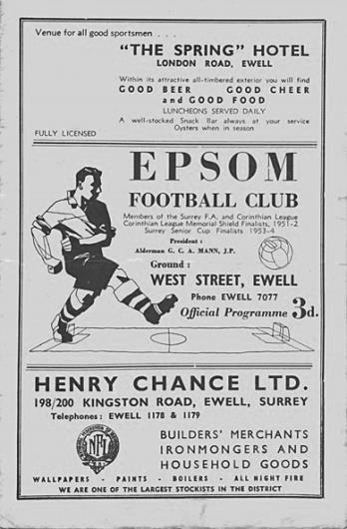
61 years ago today we edged past professional Kent League side Dover in the F.A. Cup by three goals to two at West Street with goals from Jan Sorensen, Dave Hermitage and Gordon Cairns. (see programme pictured). Our keeper Geoff Porter played an especially good game this day to help our boys to a memorable win, yet just four weeks later and two rounds further on in the competition we let a half time lead slip as we were knocked out by Margate and Porter got the blame, particularly in the local press. However, what many people didn’t know was that our keeper had chipped a bone in his thumb in the first half and couldn’t hold the ball in the second. After a bit of time off to recover from the injury Geoff decided to end his career with us and become a police officer. Geoff is 83 now and came up to a couple of our matches last season. He is still a supporter of the club despite the way he was treated back then.

28 years ago today we defeated Feltham 4-0 at West Street in an Isthmian League Division Two South match at West Street with Brian Perkins scoring twice and Marc Flemington and Tim Tweedy netting the others. This match was the last occasion that we failed to issue a match programme for a home match, as there had been an issue with the printer that day! We probably got fined for it though!

From behind the goal
Badshot Lea 1 - 4 Epsom & Ewell
Combined Counties League - Premier Division - Saturday 17th September 2016

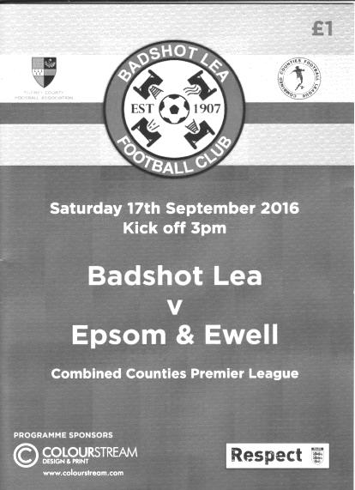
Salts made to wait before clinching the points

To look at the result only, you might think this was a comfortable away win against Badshot Lea at their temporary home of Ash United, and in some ways, it was. However, the teams were level for almost an hour and it required two late goals before we were finally able to relax with the points confirmed.

We faced some problems before this match due to a number of absences. Already short of players as a result of injuries, Captain Dan Dean had to pull out with flu on the eve of the match while both Tom Neale and Sam Robinson were on holiday and Charlie Clark-Gleave was unavailable. This left us with just 14 available players, one of which was the injured Matt Ferdinando and another was Assistant Manager Matt Smith, who hadn't taken the field for us since January 2015 at Ashford Town (Mx). Surely he wouldn't get on! In terms of the starting eleven though, Craig Hastings for Dean was the only change from the team that had drawn with Camberley Town seven days previously.

In that match we were unable to find the net, but within 70 seconds of this encounter we were ahead after a Rob Hendry corner was brought down by Daryl Cooper-Smith who then lashed the ball into the top corner from about ten yards for his twelfth goal of the season. Our leading scorer is a Liverpool fan and he had clearly been watching their win at Chelsea from the night before as he nearly emulated Jordan Henderson's strike a few minutes later but his shot from a similar distance was about a foot wide of Pat Kinsella's far post. He then set up Hendry in a good position but he was unable to find the target from fairly close range and moments later Matt Farrell was on the end of a Cooper-Smith cross but was unable to keep the header down. All this occurred in the opening six minutes of the game!

Understandably it was frustrating to players, supporters and Management alike to then concede an equaliser in the ninth minute when a pinpoint cross from the left wing was headed in by the unmarked Jacob McDonald, giving Michael Eacott no chance.

Despite the equaliser, we continued to retain a large amount of possession and you felt that it was just a matter of time before we would be back in the lead, but it is rarely as simple as that. On the half hour James Taylor met an Agi Panayiotou corner with a thumping header that was cleared off the goal line for a corner by the head of Gav Muir, while three minutes later Cooper-Smith put the ball into the path of Jordan Gallagher on the left but with Reisse

Griffin waiting unmarked in the centre our winger was unable to get neither shot nor cross in and the chance was gone. Gallagher had come on for the injured Hendry just before the half hour with what looked quite a serious ankle injury after his foot got caught in the turf.

As the half ended the game became a little more even and for the first time I started to wonder whether we might not break through after all. This view was reinforced when Griffin's dangerous low ball into the six yard box was met by a touch from Gallagher but somehow his contact sent the ball just over the bar from close range.

We started the second half positively and Griffin set up our young full back Adam Heagney and his shot from the edge of the area nearly beat Kinsella but he was able to reach the ball at full stretch. The home side headed goalwards from a corner but Eacott was there to make the save before the action returned to the other end. Cooper-Smith saw his twenty-five yard strike tipped over for a corner but wouldn't be denied for long. In the 61st minute Gallagher got down the left and laid the ball back to Alex McKay whose first time delivery in was controlled and then slotted past the advancing Kinsella. The home side appealed for offside but our man had been flagged on four occasions in the previous ten minutes and it didn't come up this time, so clearly couldn't have been!

This was a massive relief but following that we should have killed the match off in the 68th minute when Farrell made a run down the right wing and laid the ball back for Griffin to deliver in to Cooper-Smith, but instead of striking the ball at goal from close range he chose to control it first and as a result was forced wide by Kinsella. The delay enabled defenders to get back and by the time our man got the ball back in the danger was cleared. The chances continued and Griffin put over a deep cross that Kinsella got a hand to but it looped up and at the far post Gallagher went for goal with his header instead of knocking the ball back across to two waiting players and missed the target. However, he redeemed himself with some good work down the left in the 86th minute, finding Cooper-Smith who rolled the ball into the path of the advancing Farrell to poke the ball past Kinsella from eight yards to make the score 3-1.

At that point the limping Matt Tanton went off to be replaced by Smith, making his 135th appearance but his first for 20 months. His first pass sent the ball forty yards, landing directly on top of the hedge surrounding the ground, but in the 93rd minute a clever pass from Panayiotou put him in and his low shot was only half stopped by Kinsella and the ball dribbled over the line to register his eleventh goal for the club.

It was the very last kick of the game with no chance even to restart and we were celebrating our ninth win in our last eleven away matches. It was a thoroughly deserved victory against a team who will need to improve if they are to avoid a relegation battle, and although deserved on the balance of play, the three goal win looked very unlikely for quite some time as chances came and went. As we go into a set of three fixtures against teams in the top four we need to be a little more clinical when we get the chance but with a key suspension looming we could do with a few more players or we might see another Smudger cameo appearance shortly!

Epsom and Ewell: Michael Eacott, Adam Heagney, Matt Tanton, Craig Hastings,
James Taylor, Savvas 'Agi' Panayiotou, Rob Hendry, Matt Farrell (c),
Daryl Cooper-Smith, Alex McKay, Reisse Griffin

Subs: Jordan Gallagher for Hendry (28), Matt Smith for Tanton (86)

Knaphill F.C. – History
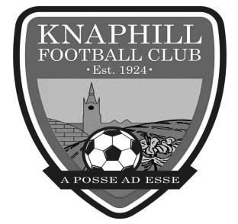
Knaphill Football Club began its life in 1924 at Waterer's Park, which was left to Woking Urban District Council in 1924 by Mr Anthony Waterer of Knaphill Nursery. The Recreation Ground was originally part of the nursery called "Blue Gates Field" and the park was laid out by Woking Council between 1924 and 1928. Very little history is known or available about the Club between 1924 and 1980. In 1980, Knaphill were represented in the Old Woking and District League (now Guildford and Woking Alliance League) in Division 3 under Manager Dave Holloway. Dave took them from Division 3 through promotion to the Surrey Intermediate League.

Mick Garbutt became the Manager of Knaphill in 1990, but in 1994 departed to join up with Colin Lippiatt and Geoff Chapple at Woking. In 1996 David Freeman took over from First Team Manager Greg Anderson, who was in charge for just one season 1995/96. Sean Carrigy was Reserve Team Manager. Season 2002/03 saw 2 new men at the helm with Mick Garbutt in charge of the 1st Team and Frank Walters the Reserves.

Season 2005/2006 was destined to be a big season for the club with the club established at new ground at Redding Way and the’ A’ team reverting back to Waterers Park having had the facilities rebuilt. 1st Team Manager David Freeman continued in charge for the 2005/2006 campaign and appointed former professional with Bristol City, Bob Pritchard, who had also managed at senior level with Chertsey Town. The 2005/2006 season did prove successful as we won the Division One title on the last day of the season against nearest rivals Virginia Water and gained promotion to the Premier Division.

2006/2007 continued with David Freeman in charge of the 1st Team who claimed back to back titles by winning the Premier Division Championship which resulted in us achieving promotion to the Combined Counties Football League, the most successful period in the clubs history up to then. Bob Pritchard took over from David Freeman as Manager who then became Bob’s assistant during September 2007. They took the team to a very commendable 7th place in the CCL, our first in senior football. Steve Hutton led the Reserves campaign, with a massive 40 games in the season.

The 2008/09 season started with former Bisley and Farnborough Assistant Manager, Ian Savage joining the Club as player/coach. The team kept a high profile in the League staying in the top half of the table all season, eventually finishing in fifth place. They could have become champions had they won their last game of the season when, in a tightly bunched set of teams in the top six, Knaphill needed to win at Farleigh to pip Staines Lammas to the title. Disappointingly they lost 3-2 and came fourth, so near yet so far.

The 2009/10 season saw the team finish third in Division One, their best placing in the three seasons in the Combined Counties League. Third would normally have gained the Club promotion, but due to the proposed floodlights installation being delayed, Knaphill had to make another challenge for promotion in 2010/11. The team won 26 out of their 40 league games, losing 10 with 4 drawn, scoring 98 goals and finished with 82 points.

Season 2010/11 was one of two halves for the first team, having suffered a poor string of results in the first four months of the season the turn of the year went onto see an unbeaten run of 12 matches. But the run was not enough to see us get close enough to a promotion place, and after reaching fifth in the table in the final run in. The newly formed Knaphill Youth U18s, played their first season in the Allied Counties League, and reached the final of the Grant McLellan Youth Cup, but lost 2-0 to Bedfont Sports.

The 2011/12 season saw Knaphill entering the FA Vase for the first time, and the team finished 12th in Division One. Our Youth team reached the Grant McLellan Cup final for the second year running, but were beaten finalists. Chairman Terry Chapman stood down as Chairman, and David Freeman, 16 years at Knaphill, took over the role in the first half of the season. Season 2012/13, the 1st team finished 12th in Division One.

Season 2013/14 emerged with Phil Ruggles as 1st team Manager, and Steve Pearman as his Assistant, and player wise, many new faces in the squad. It was Knaphill’s seventh season in the Combined Counties League, and it proved to be a season that showed more progression for the Club with promotion to the Premier Division! There was also a nice ‘mini run’ in the FA Vase with wins over Badshot Lea, Tadley Calleva and Dorking, before going out of the competition at home to East Preston.

More progress came in the Club’s 90th year when the 2014/15 season saw Knaphill make their debut in the Premier Division, and entry into the FA Cup for the first time. It was a tough first season in the Premier, but they stabilised their position and April was their best month of the League season with an unbeaten sequence with four wins and a draw, accumulated 13 points out of a possible fifteen, to push the team up to a healthier finish in the League, just a couple of points under the halfway placings in the table. In the FA Cup and FA Vase the team played three rounds in both Competitions. Wins against Fairford Town and Badshot Lea before losing to Fleet Town in the FA Cup, whilst in the FA Vase saw wins at Woodley Town and Lordswood, and like the FA Cup, lost in their third match of the FA Vase away to Hanworth Villa.

The Club were in the Surrey Senior Cup for the first time during last season, but were knocked out of the competition by Colliers Wood. Manager Phil Ruggles left the Club in January with Keith Hills taking over as caretaker Manager for the remainder of the season.

2015/16 was another record breaking year with a fine 5th place finish in the Premier Division and a superb FA Vase run defeating Cray Valley, Tunbridge Wells and Ashford Town before losing a close game to Kidlington FC. In the FA Cup we lost to Highworth Town. The Reserves won promotion to the Suburban Football League Premier Division and were Runners Up in the SL Challenge Cup Final. The Youth Team made history by winning for the first time in the FA Youth Cup when they thrashed Redhill Youth.

2016 sees Kevin Bailey join as Assistant Manager in place of David Johnston and Richard Keown taking charge of the Reserve Team and the First team have made a fine start to the season with an FA Vase campaign still to commence, due to an exemption gained because of last year’s Fourth Round appearance.

Centre page for results

Centre page for results

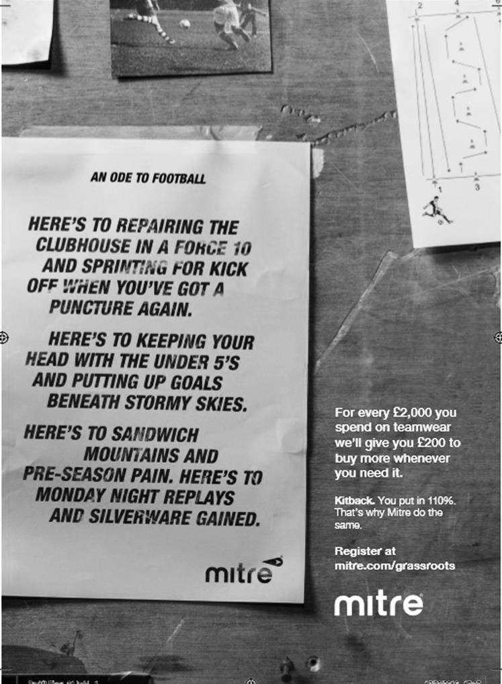

Every Opponent A-Z
Over the years we have played many, many different opponents. Exactly how many is a difficult question, as it all depends on your definition. Are Camberley & Yorktown different to Camberley Town, or are Epsom Town different to Epsom F.C. or Epsom & Ewell F.C.?

In my analysis I have classed both of the above examples as the same team, and will work through them all from A to Z. Some we have played many times, whilst others we have met just once or twice. Enjoy!

Summerstown: Played 3 - W0 D0 L3 - F4 A11 - PPG - 0.00
A great number of you will not have heard of Summerstown, but like Nunhead, another club I have recently covered, they were a very large pre-war club that disappeared almost overnight.

Whilst Nunhead were at the very pinnacle of the Amateur game, the Isthmian League, Summerstown were effectively one level below them in the Athenian League. This was an extremely strong league in its own right with clubs like Barnet, Enfield, Kingstonian, Bromley, Wimbledon and Sutton United amongst its ranks and they joined immediately after the conclusion of the First World War from the Spartan League. They had actually been elected to the Athenian for the 1914/15 season but had to wait until hostilities had ceased before being able to take their place at the new level.

Summerstown itself is a tiny district in between Earlsfield and Wimbledon and the club used to play to the side of Garrett Lane, not far from Earlsfield station. They held their own against these clubs with a high point of third place behind Champions St Albans City in the 1921/22 season.

By the time we met them, we were a Surrey Senior League team and they were beginning to struggle in the Athenian League. Our first meeting came on 23rd January 1926 in a Surrey Senior Cup tie, but despite our eventual league title that season they defeated us 4-2 at West Street, with Reg Marlow scoring our two goals.

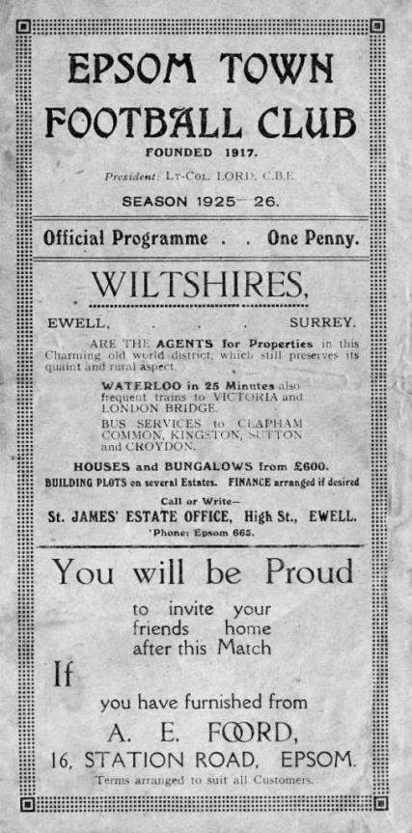
Our final two meetings came in the 1927/28 season by which time we were just one level below them, playing in the London League, a competition we would win this season, yet still lost both matches. The first, a friendly on 3rd September 1927 was lost at Garratt Lane by two goals to one and we returned there on 18th February 1928 for a Surrey Senior Cup Quarter-Final, where we led early and dominated for a while, but were 3-1 down by half time and were humbled 5-1 in the end with Fred Watts scoring our consolation in both matches.

I don’t know when Summerstown first realised they were in trouble, but the papers that day referred to the ground being in a terrible condition, so maybe they already knew and could see little point in spending any more time on it. Then by the summer of 1928 they completed their league fixtures to finish tenth out of 14, but lost their ground and folded immediately. No phoenix club rising from the ashes, or supporter movement to get the club a new ground, despite decent support. In fact, just over 2,000 had watched their match against us in the February. It just happened and everyone seemed to accept it in those days.

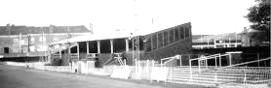
Looking back it is hard to see how they survived for so long. With an ambitious club by the name of Wimbledon on their doorstep and Kingstonian down the road, not to mention the pull of league clubs like Chelsea and Fulham within a couple of miles, survival must have been very difficult and I wonder how long they would have survived even had they been able to remain at Garratt Lane.

The ground was built on shortly afterwards but that’s not quite the end of the story. Their main stand was purchased by Wealdstone who replaced them in the Athenian League in 1928 and it would survive throughout Wealdstone’s glory days of the 80s back when players like Vinnie Jones and Stuart Pearce used to grace the Lower Mead ground, eventually being demolished in the early nineties when Wealdstone had to leave for a nomadic existence.

Above: a 1920s picture of Garratt Lane with the main stand visible on the right,
and below it a larger picture of the main stand in place at Wealdstone by this time

First Eleven Appearances 2016/17 - (max 11)
Name | Debut | 2016/17 |  |  |  | Career Totals
 |  | App | Sub | Total | Goals | App | Sub | Total | Goals
CLARK-GLEAVE Charlie | 23/08/2016 | 1 | 0 | 1 | 0 | 1 | 0 | 1 | 0
COOPER-SMITH Daryl | 03/01/2015 | 11 | 0 | 11 | 13 | 41 | 8 | 49 | 33
DEAN Dan | 02/08/2014 | 5 | 1 | 6 | 0 | 73 | 5 | 78 | 2
EACOTT Michael | 02/08/2014 | 8 | 0 | 8 | 0 | 93 | 1 | 94 | 0
FARRELL Matt | 02/08/2014 | 11 | 0 | 11 | 7 | 97 | 4 | 101 | 25
FERDINANDO Matt | 20/09/2014 | 3 | 1 | 4 | 1 | 56 | 7 | 63 | 15
GALLAGHER Jordan | 07/08/2016 | 2 | 7 | 9 | 2 | 2 | 7 | 9 | 2
GRIFFIN Reisse | 08/08/2015 | 9 | 1 | 10 | 0 | 37 | 7 | 44 | 2
HASTINGS Craig | 08/08/2015 | 7 | 2 | 9 | 0 | 44 | 6 | 50 | 0
HEAGNEY Adam | 16/08/2016 | 6 | 2 | 8 | 0 | 6 | 2 | 8 | 0
HENDRY Rob | 08/08/2015 | 8 | 3 | 11 | 1 | 38 | 14 | 52 | 13
MCKAY Alex | 20/12/2008 | 3 | 2 | 5 | 0 | 111 | 32 | 143 | 8
NEALE Tom | 13/10/2015 | 3 | 4 | 7 | 4 | 19 | 23 | 42 | 14
NORTH Rhys | 16/08/2015 | 2 | 2 | 4 | 0 | 19 | 9 | 28 | 1
PANAYIOTOU Savvas | 03/01/2015 | 6 | 2 | 8 | 0 | 38 | 10 | 48 | 7
PRICE Matt | 23/08/2016 | 2 | 0 | 2 | 1 | 2 | 0 | 2 | 1
ROBINSON Sam | 22/10/2011 | 7 | 1 | 8 | 1 | 61 | 6 | 67 | 14
SMITH Matt | 08/08/2009 | 0 | 1 | 1 | 1 | 91 | 44 | 135 | 11
TANTON Matt | 02/08/2014 | 9 | 1 | 10 | 0 | 66 | 5 | 71 | 2
TAYLOR James | 26/08/2013 | 11 | 0 | 11 | 0 | 97 | 12 | 109 | 6
THOMPSON Elliott | 09/02/2016 | 3 | 0 | 3 | 1 | 7 | 9 | 16 | 1
TURPIE Alistair | 31/03/2016 | 3 | 0 | 3 | 0 | 5 | 0 | 5 | 0
WATRET Jack | 02/08/2016 | 1 | 0 | 1 | 0 | 1 | 0 | 1 | 0

CCL Premier Division Club Directory
ABBEY RANGERS Telephone: 01932-422962 - Ground: Addlestone Moor, Addlestone, Surrey KT15 2QH - Colours: Black & White Stripes/Black/Black

A.F.C. HAYES Telephone: 0208-845-0110 - Ground: Farm Park, Kingshill Avenue, Hayes, Middx. UB4 8DD - Colours: Blue and White Stripes/Blue/Blue

BADSHOT LEA Telephone: 01252-320385 - Ground: Ash United FC, Shawfield Stadium, Youngs Drive, Shawfields Road, Ash, Hampshire. GU12 6RE - Colours: Claret/White/Claret

BEDFONT & FELTHAM Telephone: 0208 890 7264 - Ground: The Orchard, Hatton Road, Bedfont, Middx TW14 9QT - Colours: Yellow & Blue/Blue/Blue

BEDFONT SPORTS Telephone: 0208-831-9067 - Ground: Bedfont Sports Club, Hatton Road, Bedfont, Middx TW14 8JA - Colours: Red & Black Hoops/Black/Red & Black Hoops

CAMBERLEY TOWN Telephone: 01276-65392 - Ground: Krooner Park, Wilton Road, Camberley, Surrey. GU15 2QW - Colours: Red & White Stripes/Blue/Red

CB HOUNSLOW UNITED Telephone: 0208 890 7264 - Ground: The Orchard, Hatton Road, Bedfont, Middx TW14 9QT - Colours: Green/Black/Green

CHERTSEY TOWN Telephone: 01932-561774 - Ground: Alwyns Lane, Chertsey, Surrey. KT16 9DW - Colours: Royal Blue & White Stripes/Royal Blue/Royal Blue

COLLIERS WOOD UNITED Telephone: 0208-942 8062 - Ground: Wibbandune Sports Ground, Robin Hood Way, Wimbledon. SW20 0AA - Colours: Blue & Black Stripes/Black/Black
EPSOM & EWELL Telephone: 01737-553250 - Ground: Chipstead FC, High Road, Chipstead, Surrey. CR5 3SF - Colours: Royal Blue & White Hoops/Royal Blue/Royal Blue

FARNHAM TOWN Telephone: 01252-715305 Ground: Memorial Ground, Babbs Mead, West Street, Farnham, Surrey. GU9 7DY Colours: - Claret & Sky Blue /White/ Claret & Sky Blue

GUILDFORD CITY Telephone: 01483-443322 - Ground: The Spectrum, Parkway, Guildford, Surrey. GU1 1UP - Colours: Red & White Stripes/Black/Black

HANWORTH VILLA Telephone: 0208-831-9391 - Ground: Rectory Meadows, Park Road, off Hounslow Road, Hanworth, Middlesex. TW13 6PN - Colours: Red & White Stripes/Black/Black

HARTLEY WINTNEY Telephone: 01252-843586 - Ground: Memorial Playing Fields, Green Lane, Hartley Wintney, Hants RG27 8DL - Colours: Orange & Black/ Orange /Orange

HORLEY TOWN Telephone: 01293-822000 - Ground: The New Defence, Anderson Way, Court Lodge Road, Horley, Surrey. RH6 8SP - Colours: Claret & Sky Blue/Claret/Claret

KNAPHILL Telephone: 01483-475150 - Ground: Brookwood Country Park, Redding Way, Lower Guildford Road, Knaphill, Surrey. GU21 2AY - Colours: Red/Black/Red

NORTH GREENFORD UNITED Telephone: 0208 422 8923 - Ground: Berkeley Fields, Berkeley Avenue, Greenford, Middx UB6 0NX - Colours: Royal Blue & White/Royal Blue/Royal Blue

SUTTON COMMON ROVERS Telephone: 01932-866386 - Ground: Sutton United FC, Gander Green Lane, Sutton, Surrey SM1 2EY - Colours: Yellow/Black/Black

RAYNES PARK VALE Telephone: 020-8540-8843 - Ground: Prince Georges Playing Field, Grand Drive, Raynes Park, London. SW20 9NB - Colours: Blue/Blue/Red

SPELTHORNE SPORTS Telephone: 01932-961055 - Ground: Spelthorne Sports Club, Staines Road, Ashford Common, Ashford, Middx. TW15 1RY - Colours: Light & Dark Blue/Dark Blue/Light Blue

WALTON & HERSHAM Telephone: 01932 245263 - Ground: Stompond Lane, Walton on Thames, Surrey KT12 1HF - Colours: Red/Red/Red

WESTFIELD Telephone: 01483-771106 - Ground: Woking Park, Kingfield Road, Woking, Surrey. GU22 9BA - Colours: Yellow/Black/Black

WINDSOR Telephone: 01753-860656 - Ground: Stag Meadow, St Leonards Road, Windsor, Berks SL4 3DR - Colours: Red/Red/Red

Combined Counties League Premier Division Opponents
All-time Records
incl Saturday 17th September | P | W | D | L | F | A | PPG | GD | Best  Win | Worst  Loss
Bedfont & Feltham | 1 | 1 | 0 | 0 | 9 | 2 | 3.00 | +7 | 9-2 | X
Abbey Rangers | 2 | 2 | 0 | 0 | 8 | 1 | 3.00 | +7 | 7-1 | X
Spelthorne Sports* | 5 | 4 | 1 | 0 | 15 | 6 | 2.60 | +9 | 6-2 | X
Sutton Common Rovers | 10 | 8 | 1 | 1 | 27 | 12 | 2.50 | +15 | 4-0 | 1-4
Horley Town | 29 | 20 | 5 | 4 | 65 | 30 | 2.24 | +35 | 6-0 | 1-3
Colliers Wood United | 22 | 14 | 2 | 6 | 45 | 33 | 2.00 | +12 | 4-0 | 0-5
Westfield | 18 | 11 | 3 | 4 | 39 | 29 | 2.00 | +10 | 6-1 | 0-4
Bedfont Sports | 9 | 5 | 2 | 2 | 13 | 10 | 1.89 | +3 | 3-0 | 0-4
Farnham Town | 13 | 7 | 2 | 4 | 23 | 22 | 1.77 | +1 | 3-1 | 1-4
Guildford City | 16 | 9 | 1 | 6 | 32 | 22 | 1.75 | +10 | 5-1 | 1-5
Hanworth Villa | 14 | 7 | 3 | 4 | 34 | 24 | 1.71 | +10 | 5-0 | 1-4
Raynes Park Vale | 26 | 13 | 5 | 8 | 57 | 36 | 1.69 | +21 | 6-1 | 0-2
Knaphill | 6 | 3 | 1 | 2 | 11 | 8 | 1.67 | +3 | 4-1 | 1-2
Walton & Hersham | 49 | 24 | 9 | 16 | 100 | 96 | 1.65 | +4 | 6-0 | 0-8
Camberley Town* | 89 | 38 | 22 | 28 | 158 | 123 | 1.52 | +35 | 9-1 | 0-4
Hartley Wintney | 10 | 4 | 3 | 3 | 25 | 17 | 1.50 | +8 | 5-0 | 2-4
Badshot Lea | 18 | 8 | 3 | 7 | 35 | 34 | 1.67 | +1 | 4-1 | 0-4
Windsor | 48 | 18 | 12 | 18 | 88 | 90 | 1.38 | -2 | 4-0 | 0-6
Chertsey Town | 47 | 17 | 5 | 25 | 70 | 86 | 1.19 | -16 | 3-0 | 0-7
AFC Hayes | 8 | 2 | 2 | 4 | 16 | 15 | 1.00 | +1 | 7-0 | 0-3
CB Hounslow United | 2 | 0 | 0 | 2 | 2 | 7 | 0.00 | -5 | X | 1-5
* includes one abandoned match v Camberley and one loss on penalties v Spelthorne

EL Records Premier Challenge Cup
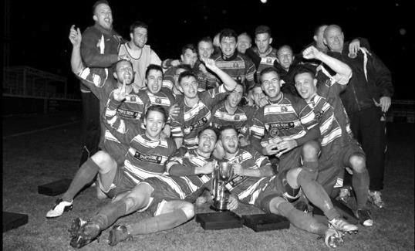
First Round
Redhill | 4-0 | Bedfont & Feltham
Match played at Bedfont & Feltham F.C.
Spelthorne Sports | 4/10 | Sutton Common Rovers
Knaphill | 0-2 | Camberley Town
Worcester Park | 24/9 | Dorking
Epsom & Ewell | 1-0 | Abbey Rangers
Westfield | 3-2 | North Greenford United
Cobham | 3-2+ | Bagshot
CB Hounslow United | 3-4 | Farnham Town
South Park Reserves | 1-4 | Balham
Second Round
Hanworth Villa | 11/10 | Epsom and Ewell
AFC Hayes | 4/10 | Balham
Epsom Athletic | 28/9 | Windsor
2 | V | Bedfont Sports
Raynes Park Vale | 4/10 | Colliers Wood United
Frimley Green | 4/10 | Banstead Athletic
Westfield | 4/10 | Redhill
Staines Lammas | 15/10 | Farnham Town
4 | V | Cove
Badshot Lea | 4/10 | Guildford City
Chertsey Town | 4/10 | Camberley Town
Cobham | 4/10 | Chessington & Hook United
Hartley Wintney | 4/10 | AC London
Horley Town | 4/10 | Sheerwater
Walton & Hersham | 4/10 | Eversley & California
Ash United | 11/10 | Farleigh Rovers

Player Sponsorship
Here is the current list for the 2016/17 season showing all of our players and Management that are currently available for sponsorship.

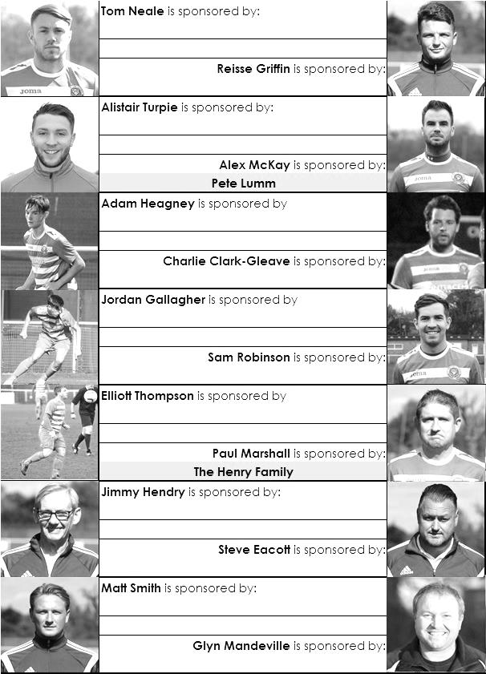

Sponsorship costs just £40 and it is easy to do. Just select a player who has not been previously sponsored and let a Committee Member know that you would like to sponsor them. Beware though. Until we have received the money it is possible for someone to jump in front of you, so don’t delay, sponsor today!
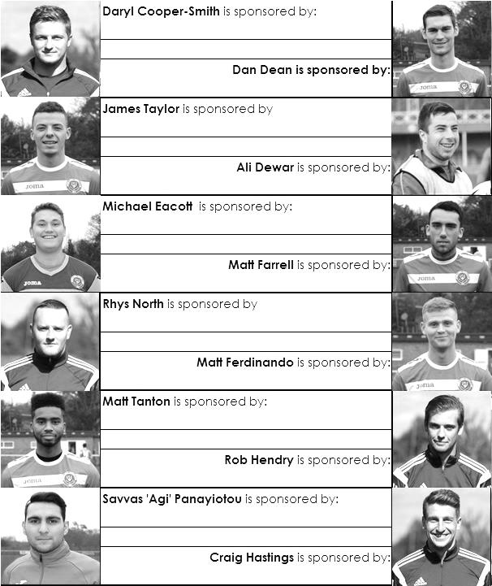

Match and Ball Sponsorships – 2016/17
Opponent | Date | Match Sponsor | Ball Sponsor
Gravesham Borough | 07/08/16 | Club President - Stella Lamont
Gravesham Borough | 07/08/16 | Relocation Committee Member - Mike Lovett
CB Hounslow United | 16/08/16 | EEFC Management Committee
Abbey Rangers | 23/08/16 | Steve & Geoff Dyke
Horley Town (11.30am) | 29/08/16 | In Memory of Chris Henry
Abbey Rangers (LC) | 06/09/16 | Paul Merritt
Camberley Town | 10/09/16 | Building Shop Ltd
Knaphill | 24/09/16 | Pete Lumm
Sutton Common Rovers | 08/11/15
Windsor | 15/11/16
Bedfont Sports | 19/11/16
AFC Hayes | 26/11/16
Chipstead (SSC) | 06/12/16
Hanworth Villa | 13/12/16
Chertsey Town | 17/12/16
Raynes Park Vale (11.30am) | 27/12/16
Spelthorne Sports | 07/01/17
Guildford City | 17/01/17
Bedfont & Feltham | 21/01/17 | Programme Editor - Richard Lambert
Badshot Lea | 04/02/17
Westfield | 18/02/17
Walton & Hersham | 04/03/17
Hartley Wintney | 18/03/17
Farnham Town | 25/03/17
Colliers Wood United (1.00pm) | 14/04/17 | Good Friday match – make a note!
North Greenford United | 22/04/17 | Club President - Stella Lamont
 | tba | F.A. Vase – if drawn at home
For League, League Cup and Surrey Senior Cup Matches:
Match sponsorship - £40.00 Match ball sponsorship - £25.00. Combined £55.00.
For F.A. Cup and F.A. Vase matches:
Match sponsorship - £50.00 Match ball sponsorship - £30.00. Combined £65.00.

Sponsorship includes: (x2 for match, x3 for match and ball)

Admission, programmes, hospitality and advertising and mascot for the day (if required).
If you are interested, just speak to a Committee Member, or drop me an email at: richard.c.lambert@gmail.com

We also thank our Kit Sponsors INTERCEM

Salts Super Six Predictor
The Salts Super Six Predictor is live again for today’s match and the tickets are on sale at today’s game to the left of the gate.

The competition is easy to play! To win, you simply need to predict the results of six matches correctly from the three options, fill in the form and make sure it is back with our seller before the deadline on the ticket. The latest fixtures are shown lower down.

If you are a club regular, you just need to place your name on the sheet, although if you aren’t, then we’ll need a contact number from you too. We will announce any winners on the website within three working days, so don’t worry, we won’t miss you!

We had a big jackpot winner last year and it is beginning to get fairly large again! It is currently £190 and you’ll always know the size of the pot before you enter.

Please note that if there is more than one winner, the prize pot would be shared between the winners. All you need to do now is have a go, as many times as you like!

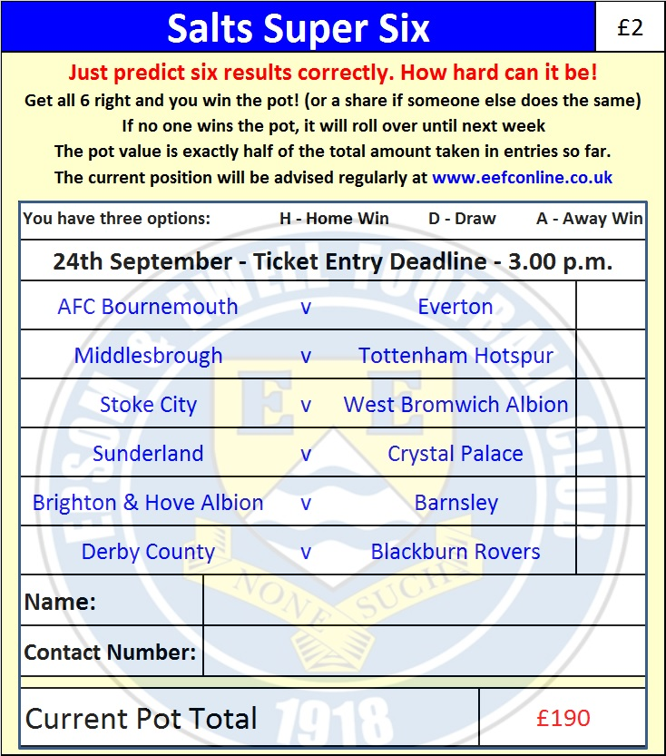

Good luck!

Combined Counties League – Premier Division
Saturday, 24th September 2016 - Kick-off 3.00 p.m.
Epsom and Ewell  (Royal Blue & White hoops) | V |  | Knaphill  (All Red)
Squad | NUMBERS
Michael Eacott |  |  | Richard Shelley
Adam Heagney |  |  | Ross Cheek
Matt Tanton |  |  | Timmy Taylor
© Dan Dean |  |  | Scott Costello
James Taylor |  |  | Chris Patterson
Savvas ‘Agi’ Panayiotou |  |  | Brad Thomas
Matt Ferdinando |  |  | Danny Taylor
Matt Farrell |  |  | Rob Kersley
Jordan Gallagher |  |  | Charlie Postance
Alex McKay |  |  | Jimmy Norman
Reisse Griffin |  |  | Jack Mazzone
Rob Hendry |  |  | Connor Close
Craig Hastings |  |  | Alex Lumley
Sam Robinson |  |  | Arafat Kabuye
Tom Neale |  |  | Josh Coke
Charlie Clark-Gleave |  |  | Josh Watkins
Alistair Turpie |  |  | Jamie Doble
Daryl Cooper-Smith |  |  | Daryn Hennessy
Matt Smith |  |  | Neil Chinnery
Glyn Mandeville | MANAGER |  | Keith Hills
Matt Smith | ASSISTANT |  | Kevin Bailey
Steve Eacott / Alex McKay / Jimmy Hendry | COACHES / PHYSIO |  | Roland Baker / Andy Rowe / Jenny Thraves
REFEREE: P.Georgiou
ASSISTANTS: C.Little, M.Swinburn
Today’s Match and Match Ball are sponsored
by our former Chairman, Pete Lumm

OUR NEXT VISITORS TO HIGH ROAD (unless drawn at home in Vase)
Sutton Common Rovers
Combined Counties League – Premier Division
Tuesday 8th November 2016 – 7.45 p.m.

